Normalization
Q1. Suppose you are given a relation R= (A,B,C,D,E) with the following functional dependencies: {CE →D, D→B, C →A}

a) Find all candidate keys. (2)

b) Identify the best normal form that R satisﬁes (1NF, 2NF, 3NF, or BCNF). (2)

c) If the relation is not in BCNF, decompose it until it becomes BCNF. At each step, identify a new relation, decompose and re-compute the keys and the normal forms they satisfy. (4)

Transaction and Concurrency Control
Q2. Consider a database with objects X and Y and assume that there are two transactions T1 and T2. T1 first reads X and Y and then writes X and Y. T2 reads and writes X then reads and writes Y. Give an example schedule formed from T1 and T2 that is not serializable. Explain why your schedule is not serializable. (4)

Q3. Optimistic Concurrency Control Consider a concurrency control manager by timestamps. Below are several sequences of events, including start events, where sti means that transaction Ti starts and coi means Ti commits. These sequences represent real time, and the timestamp-based scheduler will allocate timestamps to transactions in the order of their starts. In each case below, say what happens with the last request. You have to choose between one of the following three possible answers:
- the request is accepted,
- the transaction is delayed,
- the transaction is rolled back.

- st1; st2; r1(A); r2(A); w1(B); w2(B);
(b) st1; st2; r2(A); co2; r1(A); w1(A)
(c) st1; st2; st3; r1(A); w3(A); co3; r2(B); w2(A)
(d) st1; st2; st3; r1(A); w1(A); r2(A); (6)

Relational algebra
Q4. Consider the following Pubs Database Schema:
author(author_id, firstname, lastname)
author_pub(author_id, pub_id, author position)
book(book_id, booktitle, month, year, editor)
pub(pub_id, title, book_id)
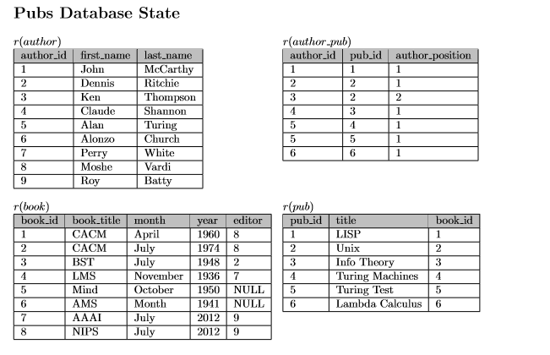
• author_id in author_pub is a foreign key referencing author
• pub_id in author pub is a foreign key referencing pub
• book_id in pub is a foreign key referencing book
• editor in book is a foreign key referencing author(author_id
• Primary keys are underlined

Write a relational algebra expression for the following: (6)
- Return the names of all authors who are book editors.
- How many tuples are returned by following relational algebra expression
- Return the names of all authors who have at least one publication in the database.

Recovery
Q5. The figure below shows the system log at the point of a system crash for a particular execution schedule of three transactions T1, T2 and T3. The values of A, B, C and D, which are used by the transactions, are shown to the right of the system log entries. Suppose that we use immediate update protocol with checkpointing. Describe the recovery process from the system crash. Specify which transactions are rolled back, which operations in the log are redone and which (if any) are undone, and whether any cascading rollback takes place. What are the values of Data Item A, B, C, D before and after recovering from the system crash.

Log | A | B | C | D
Start_transaction(T1) | 10 | 20 | 30 | 40
Read_item(T1, A)
Write_item(T1, A, 10, 8) | 8
Start_transaction(T2)
Read_item(T1, D)
Read_item(T2, B)
Write_item(T2, B, 20, 28) |  | 28
Commit T1
Start_transaction(T3)
Read_item(T2, D)
Read_item(T3, B)
Write_item(T2, D, 40, 400) |  |  |  | 400
Checkpoint
Write_item(T3, B, 28, 17) |  | 17
Commit T2
Start_transaction(T4)
Read_item(T3, C)
Read_item(T4, B)
System crash

(6)

